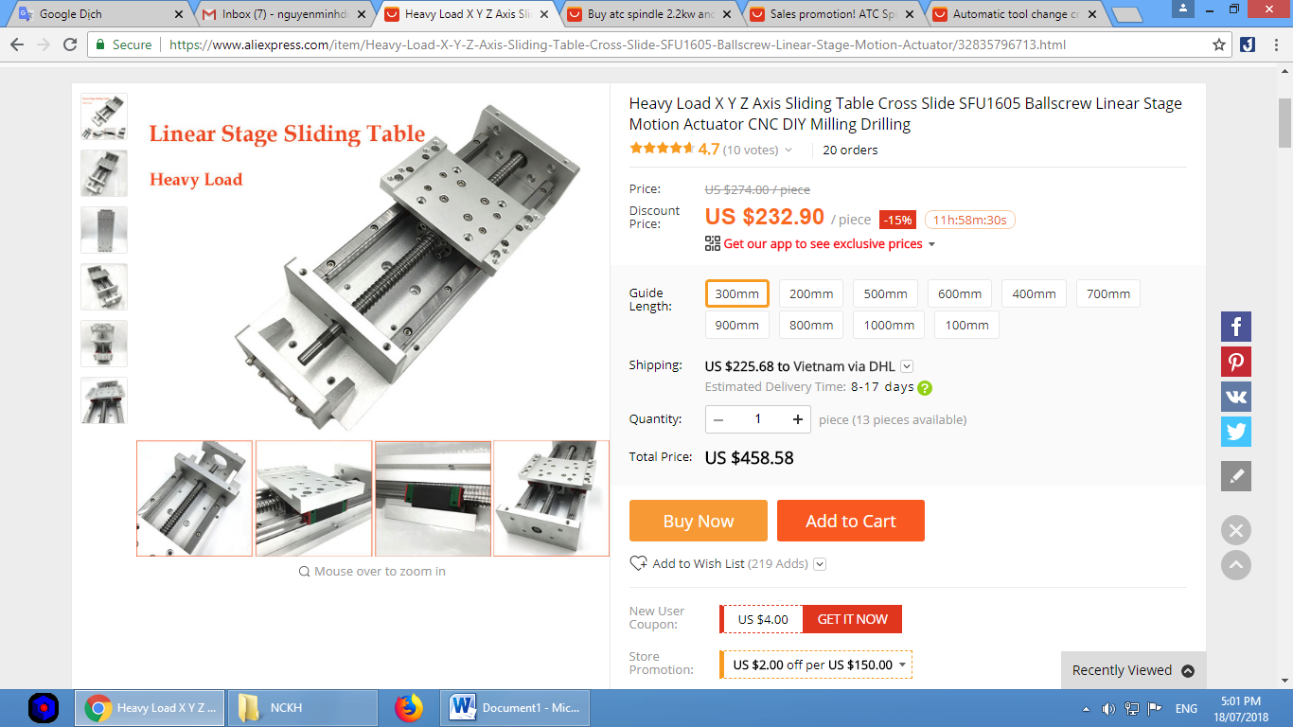

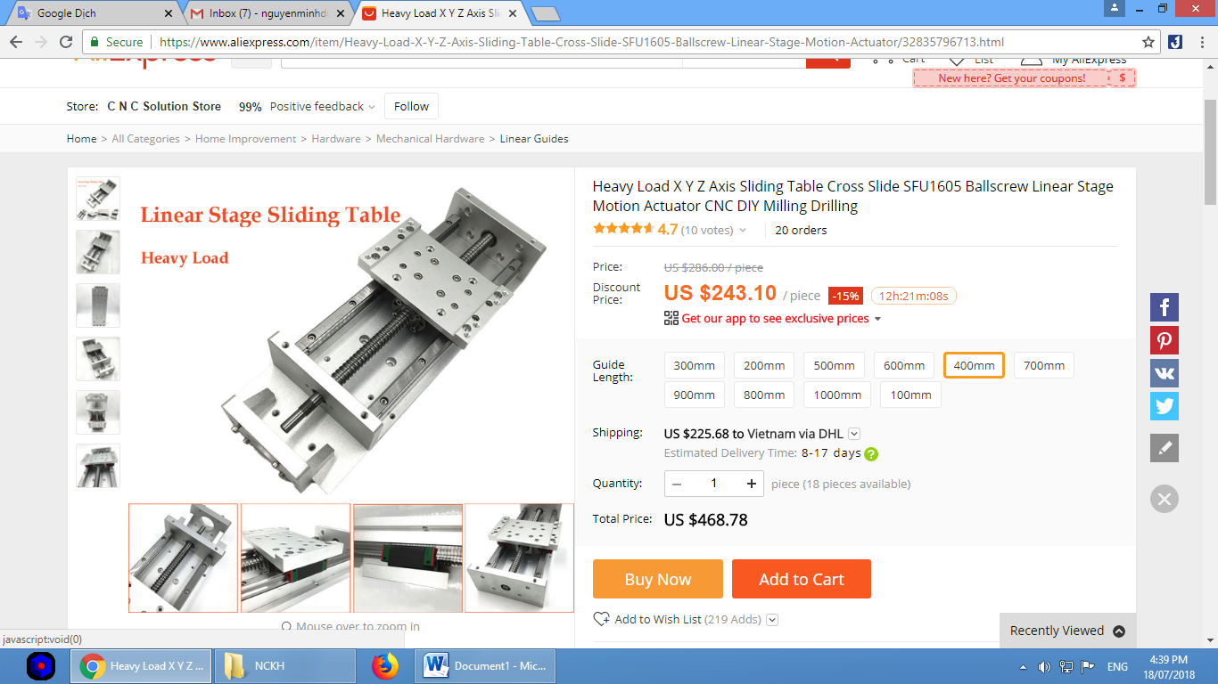

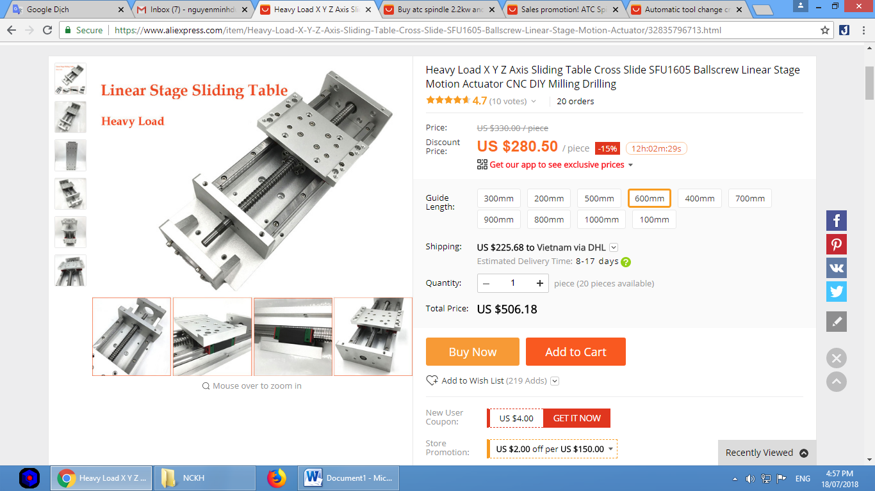
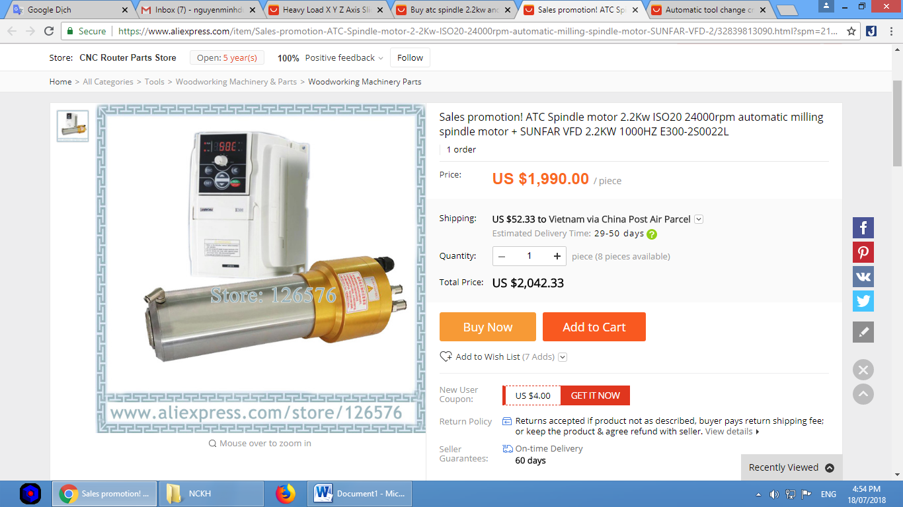

Furniture making machine / wood cutting machine 3d ABM6090C ATC

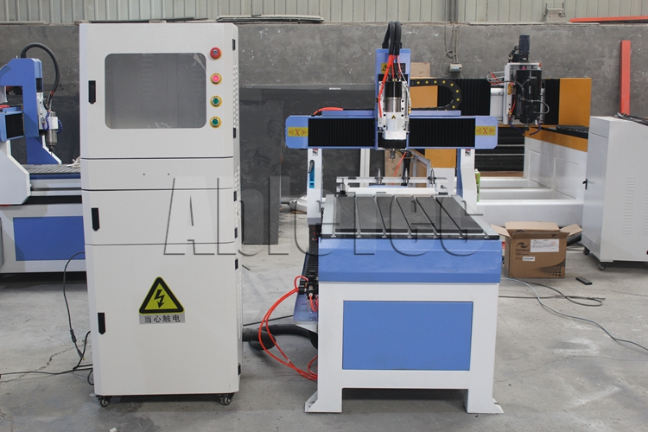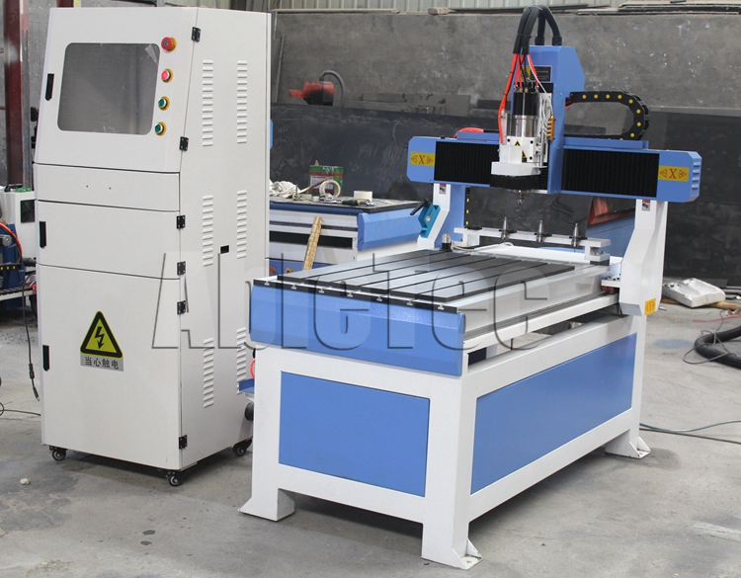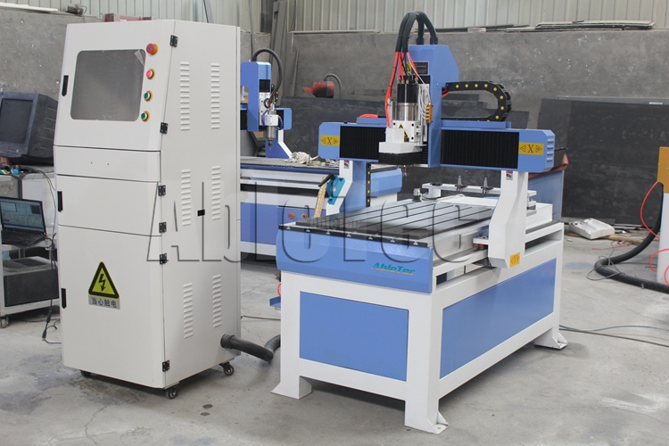
​Feature:
# Adopting advanced Mach 3 system with USB interface, operate with the convenient handle.
# Well compatibility: CAD/CAM designing software, such as type3/castmate/Artcam/wentai, etc
# Water proof and dustproof design for the CNC machine protects the transmission parts from broken.
# ATC spindle,automatic tool changer.Water tank and automatic water cooling system for cutters.
# For every set cnc stone engraving machine three axes adopt Taiwan high precision square guide rail, X,Yand Z axis adopts Taiwan screw,with high precision and longevity.
# High soft and famous brand electric cables with high abrasion, fold, high temperature, acid or alkali resistance.
# We will provide you several kinds of software for free, with English.Also you will get the picture storage with thousands of 2D and 3D designs.
Technical parameters

Model NO. | ABM6090C ATC
Working area | 600*900*200mm
Spindle | 2.2KW water cooling ATC spindle
Control system | Mach3
Rail | Taiwan Hiwin 20 rails
Transmission | Taiwan TBI ball screw transmission
Table | T-slot table
Driver | LeadshineM860
Motor | Leadshine easy servo motor HBS758
Structure | Cast iron body
Travel speed | 0~16000mm/min
Working speed | 0~8000mm/min
Working Accuracy | +/-0.01
Voltage | AC 220/380V
Circumstance temperature: | 0-45°C
Relative humidity: | 30%-75%
Command | G code, *uoo, *mmg, *plt
Warranty | 1 year
Compatible Software | Type3/Artcam/UG/Pro-E/Mastercam/Ucancam V9, etc
Packing size | 1640*1160*1600mm
Other Optional | 3.0kw,  DSP controller

Details
X Y Z axis by Taiwan TBI ball screw
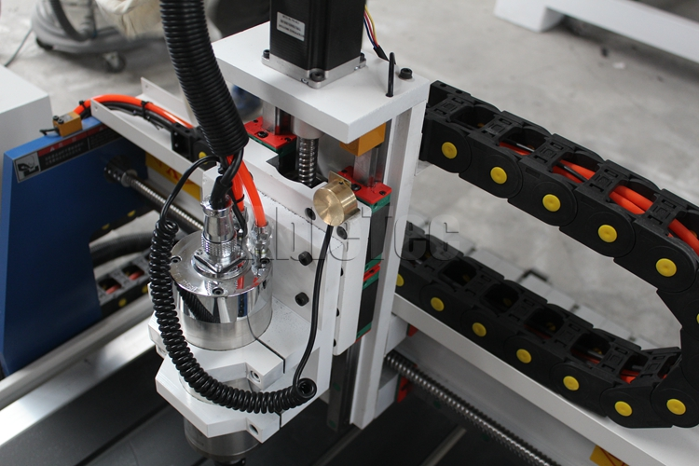
2.2KW water cooling ATC spindle
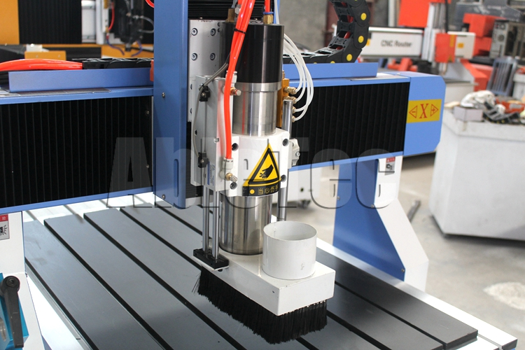
4pcs tool changer
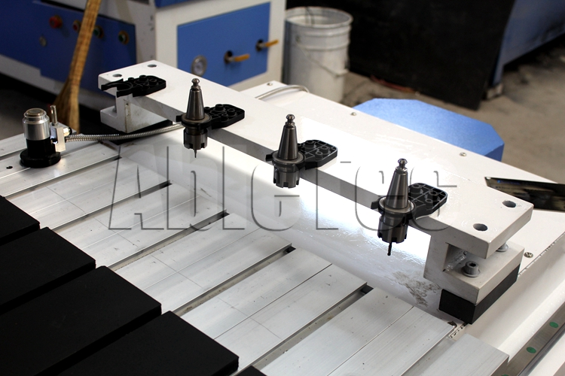
Taiwan high precision 20mm linear square rail
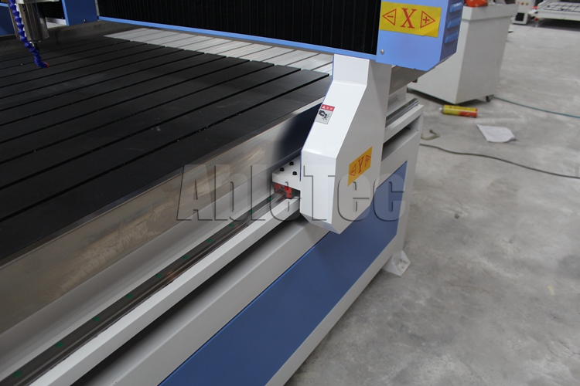
PVC T-slot table with aluminum profile

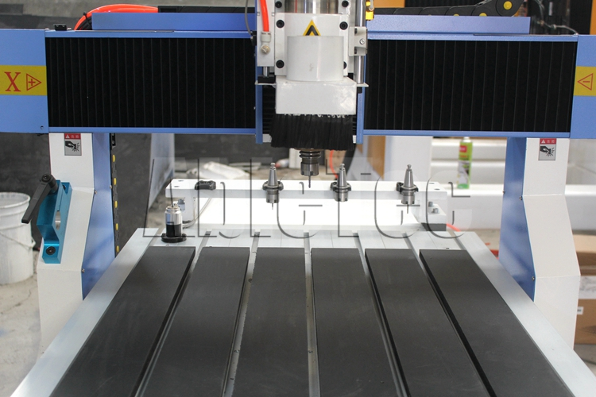
Separate control cabinet：Mach 3 controller and power sup

